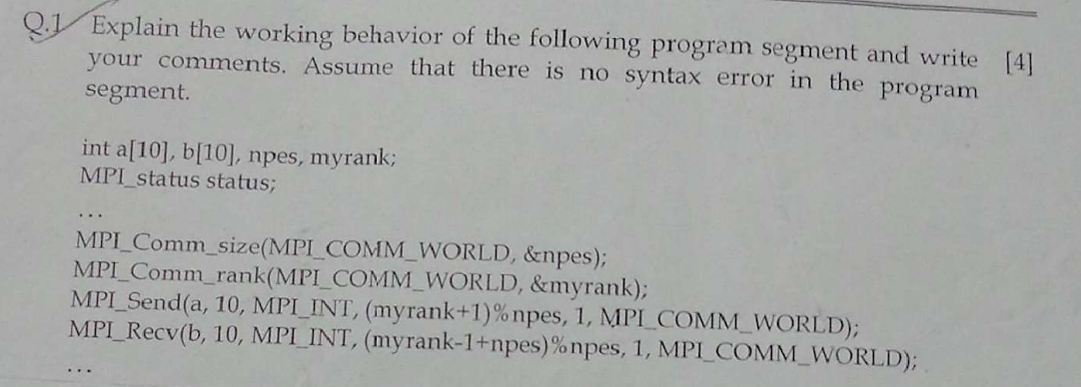

Ans:

From Bookmarked website

<http://parallelcomp.uw.hu/ch06lev1sec3.html>



Ans:

<https://www.mcs.anl.gov/~itf/dbpp/text/node22.html#SECTION02380000000000000000>

<https://www.dartmouth.edu/~rc/classes/intro_mpi/>



Ans:

Single Program Multiple Data (SPMD) model

Different processes merged into one program. Within program, control statements select different parts for each processor to execute. All executables start together -static process creation.

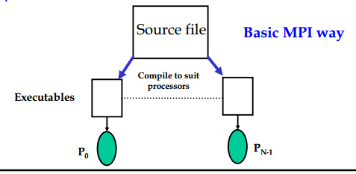

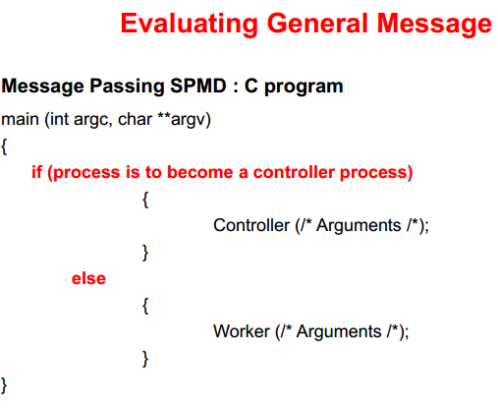



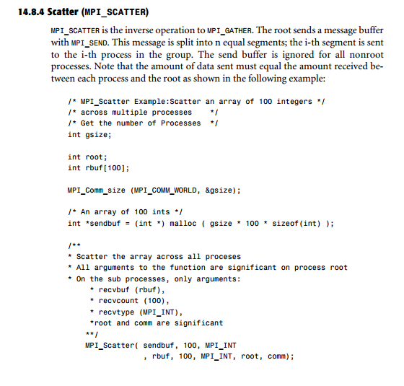

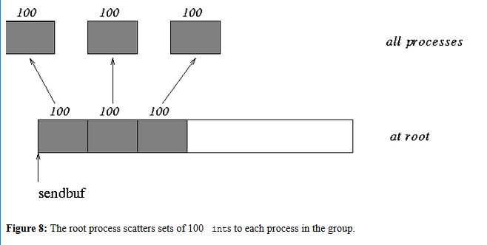

1. <http://mpi-forum.org/docs/mpi-1.1/mpi-11-html/node72.html>
2. (Programming Series) Vladimir Silva-Grid computing for developers-Charles River Media (2005).pdf
3. <https://www.mcs.anl.gov/~itf/dbpp/text/node97.html>



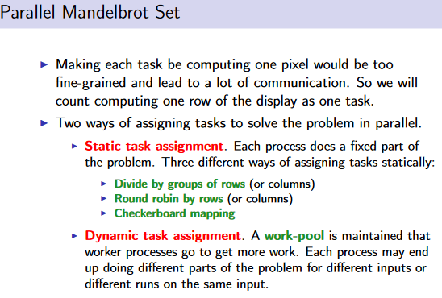

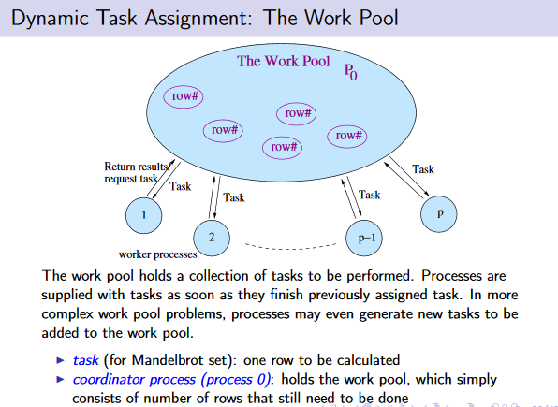

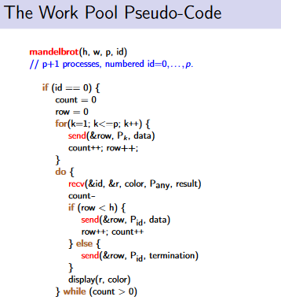

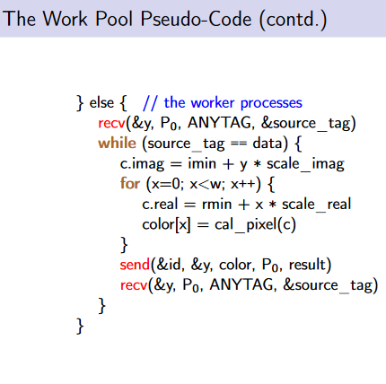

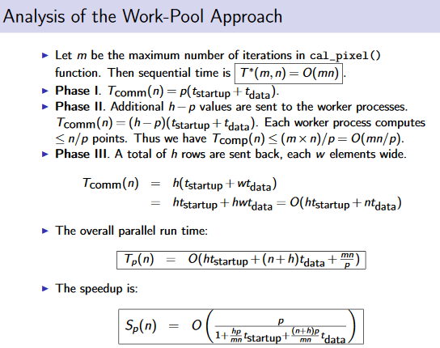

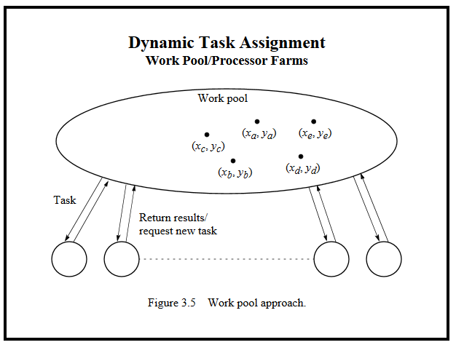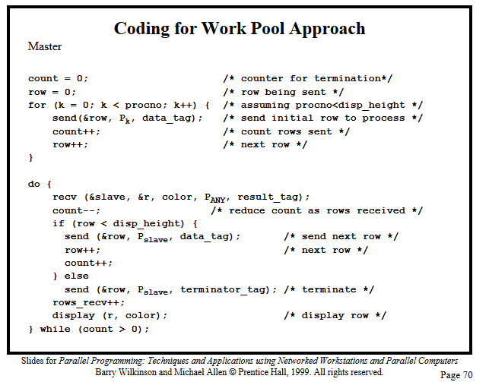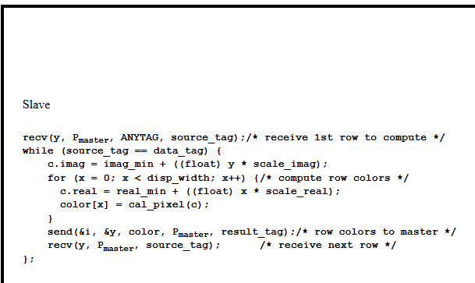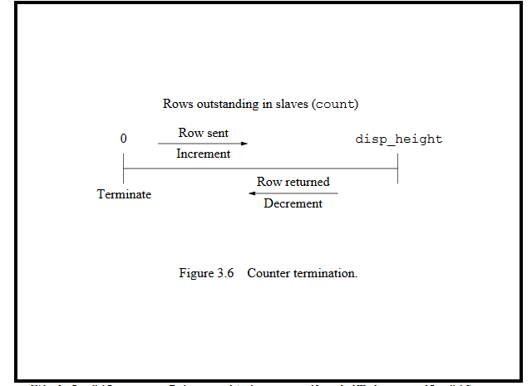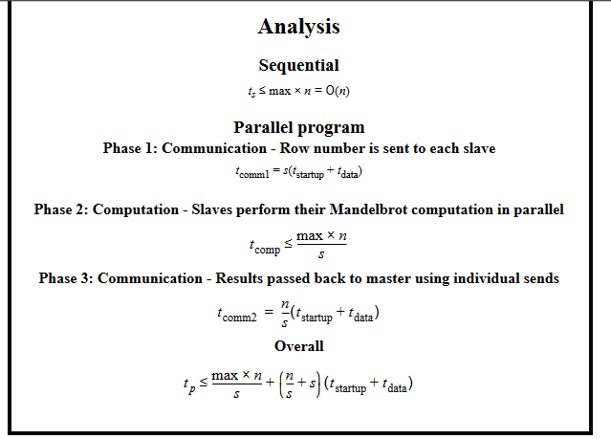

<http://cs.boisestate.edu/~amit/teaching/430/handouts/ep.pdf>

<http://www.cs.nthu.edu.tw/~ychung/slides/para_programming/slides3.pdf>

**Barry Wilkinson, Michael Allen-Parallel Programming_ Techniques and Applications Using Networked Workstations and Parallel Computers (2nd Edition) -Prentice Hall (2004) – pdf downloaded**